An Intelligent Fraud Detection System for Banking Transactions Using Machine Learning and Business Intelligence Visualisation

Table of Contents
1. Background 4
2. Introduction 4
3. Proposed Work 5
4. Research Questions 6
5. Project Requirements 6
6. Project Risks 6
7. Project Schedule (12 Weeks) 7
8. References 9

List of Figures
Figure 1: Gantt Chat 8

1. Background
The existence of digital banking and online financial services has seen a significant growth in electronic transactions across the world. Although this has made life much easier and convenient for the customers, it has also exposed the customers to more chances of financial fraud. Online banking transactions have become one of the biggest concerns for banks, financial institutions, and customers due to the potential of losing money, tarnished reputation, and lack of trust in digital banking systems (AbouGrad & Sankuru, 2025). Historical fraud detection systems are mostly rule-based systems where preset rules are applied to determine suspicious transactions. However, these systems do not cope with the emergence of new and progressive forms of fraud and thus are less efficient in countering advanced cybercriminal methods. Machine Learning (ML) has become one of the most effective solutions to fraud detection with the development of data analytics and artificial intelligence. The use of ML algorithms can work with large amounts of transaction data, detect latent patterns, and identify anomalies that can reflect fraudulent activities (Wu et al., 2025). Such models can constantly gain knowledge from new data and become more accurate over time (Hernandez Aros et al., 2024). This project is based on the creation of a machine-learning-driven fraud detection system based on the presented data of bank transactions and visual reports created with the help of Power BI dashboards that allow following the pattern of the transactions and identifying possible fraud.
Data Sources: https://www.kaggle.com/datasets/marusagar/bank-transaction-fraud-detection/data

2. Introduction
Banking institutions receive millions of transactions each day, and it is quite hard to manually detect fraud. The fraudsters are constantly working out means to evade the security mechanisms, thereby making it more difficult to detect fraud. Consequently, automated fraud detection systems are critical towards monitoring transactions and detecting suspicious behaviour in real time. Machine Learning is now a powerful fraud detection technique as it allows working with large datasets and finding complicated patterns that are not easily detected by traditional rule-based systems. Machine learning algorithms are also trained using historical data of transactions that the organisation has carried out, and can generalise new transactions as being legitimate or fraudulent. Attributes included in the dataset to be used in this project are transaction amount, customer information, type of device, merchant category, location of transaction and balance of the account. Such characteristics can be used to detect fraudulent trends. The development, training, and evaluation of machine learning models will be made based on historical data through data cleaning and feature selection as preprocessing techniques. Also, the trends in fraud, patterns of transactions, and other elements likely to raise a high-risk will be visualised using Power BI dashboards to help in improved decision-making.

3. Proposed Work
The primary aim of the project is to create a fraud detection system that could recognise suspicious bank transactions with the help of machine learning methods and provide analytical information with the use of Power BI dashboards.
Objectives of the Project
The key objectives of the project include:
- To analyse bank transaction data and understand patterns related to fraudulent activities.
- To preprocess and prepare the dataset for machine learning model development.
- To implement machine learning algorithms to classify transactions as fraudulent or legitimate.
- To evaluate the performance of different models using appropriate evaluation metrics such as accuracy, precision, recall, and F1-score.
- To develop interactive Power BI dashboards to visualise transaction patterns and fraud trends.
Methodology
The project will be implemented in several steps to realise the desired results. The dataset will be gathered and analysed to get familiar with its format and characteristics. The data will be cleaned and irrelevant information eliminated, as well as missing values, through data preprocessing methods. The feature engineering will be done to identify the most significant variables that lead to fraud identification (Baisholan et al., 2025). The attributes of transaction amount, the nature of the device, the place of transaction and the type of merchant may play an important role in fraud prediction. Logistic Regression, Decision Tree, Random Forest, and Gradient Boosting machine learning algorithms will be adopted in constructing predictive models. Such models will be trained using historical transaction information and tested using information that is not visible to determine the performance of the models. Evaluation metrics will be applied to compare the performance of the models, and they will include accuracy, precision, recall and confusion matrix. The final model of fraud detection will be the model with the best performance (Moradi et al., 2025). Finally, interactive dashboards will be created with the help of Power BI, and they will show the trends of fraud, statistics of transactions, insights into customer behaviour, and indicators of fraud risks. Such dashboards will make the results easy to interpret and track the activities of fraud against the users.

4. Research Questions
The following research questions guide the development of this project:
- How effectively can machine learning algorithms detect fraudulent bank transactions compared to traditional rule-based methods?
- Which transaction features have the most significant impact on identifying fraudulent activities?
- How can data visualisation tools such as Power BI enhance the understanding of fraud patterns in financial transactions?
- Which machine learning algorithm provides the highest accuracy and reliability in detecting fraudulent transactions?

5. Project Requirements
To complete the project, several technical and software requirements are needed.
Hardware Requirements
- Computer system with a minimum of 8 GB RAM
- Intel i5 processor or higher
- Sufficient storage space for dataset and analysis files
Software Requirements
- Python programming language
- Jupyter Notebook or Google Colab
- Machine learning libraries such as Pandas, NumPy, Scikit-learn, and Matplotlib
- Power BI for data visualisation and dashboard creation
Dataset Requirements
- Bank Transaction Fraud Detection Dataset containing transaction information, customer details, and fraud labels.

6. Project Risks
Several potential risks may affect the successful completion of the project.
- A significant threat is the imbalance of the data, in which fraudulent transactions make up a small part of the data (Yaseen & Al-Amarneh, 2025). This may result in biased models, which favour normal transactions. Such techniques as resampling or class balancing can be necessary to deal with this problem.
- Another threat is an issue with data quality, including missing values or poor data formatting that can influence the performance of the model.
- It can also be due to the risk of overfitting of the model, whereby the machine learning model works well on the training data but fails on the new unseen data (Dichev et al., 2025).
- There are also technical problems that might be encountered during the process of integrating machine learning results with the Power BI dashboards.
These risks will be reduced with the help of proper data preprocessing, model evaluation, and testing.

7. Project Schedule (12 Weeks)
The project will be implemented in a span of 12 weeks, which will be subdivided into various phases to ensure systematic development, analysis and evaluation of the fraud detection system.
Phase 1 – Project Planning and Literature Review (Weeks 1–2)
It is at this stage that the issue of interest will be established, and the scholarly sources on fraud detection and machine learning will be examined. The scope and goals of the project will be completed. The data set will also be gathered and preliminarily examined to know its format, variables, and potential challenges.
Phase 2 – Data Collection and Preprocessing (Weeks 3–4)
During this stage, data will be purged and made ready to undergo analysis. Preprocessing stages like data management of missing data, deleting unnecessary entries, and data transformation will be done. The technique of feature selection shall also be used to be able to come up with the most appropriate characteristics of detecting fraud.
Phase 3 – Machine Learning Model Development (Weeks 5–7)
Decision Tree, Random Forest, and Logistic Regression are some of the machine learning algorithms to be employed. The dataset will be divided into training and testing data, and the models will be trained to identify fraud and legitimate transactions.
Phase 4 – Model Evaluation and Visualisation (Weeks 8–10)
The performance metrics to be used to evaluate the models will include accuracy, precision, recall and confusion matrix. A Power BI dashboard will be created to model fraud trends and transactional insights.
Phase 5 – Final Report and Documentation (Weeks 11–12)
The final phase will be to write the project report, write the methodology and findings, and present the findings.
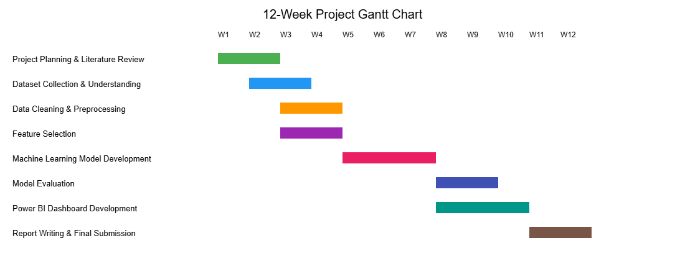
Figure 1: Gantt Chat

8. References
AbouGrad, H. and Sankuru, L., 2025. Online banking fraud detection model: Decentralized machine learning framework to enhance effectiveness and compliance with data privacy regulations. Mathematics, 13(13), p.2110. https://doi.org/10.3390/math13132110
Baisholan, N., Dietz, J.E., Gnatyuk, S., Turdalyuly, M., Matson, E.T. and Baisholanova, K., 2025. FraudX AI: An interpretable machine learning framework for credit card fraud detection on imbalanced datasets. Computers, 14(4), p.120. https://doi.org/10.3390/computers14040120
Dichev, A., Zarkova, S. and Angelov, P., 2025. Machine learning as a tool for assessment and management of fraud risk in banking transactions. Journal of Risk and Financial Management, 18(3), p.130. https://doi.org/10.3390/jrfm18030130
Hernandez Aros, L., Bustamante Molano, L.X., Gutierrez-Portela, F., Moreno Hernandez, J.J. and Rodríguez Barrero, M.S., 2024. Financial fraud detection through the application of machine learning techniques: a literature review. Humanities and Social Sciences Communications, 11(1), pp.1-22. https://doi.org/10.1057/s41599-024-03606-0
Moradi, F., Tarif, M. and Homaei, M., 2025. A systematic review of machine learning in credit card fraud detection. Preprint, MDPI AG. https://doi.org/10.20944/preprints202507.1085.v1
Wu, Y., Wang, L., Li, H. and Liu, J., 2025. A deep learning method of credit card fraud detection based on continuous-coupled neural networks. Mathematics, 13(5), p.819. https://doi.org/10.3390/math13050819
Yaseen, H. and Al-Amarneh, A.A., 2025. Adoption of artificial intelligence-driven fraud detection in banking: The role of trust, transparency, and fairness perception in financial institutions in the United Arab Emirates and Qatar. Journal of Risk and Financial Management, 18(4), p.217. https://doi.org/10.3390/jrfm18040217

